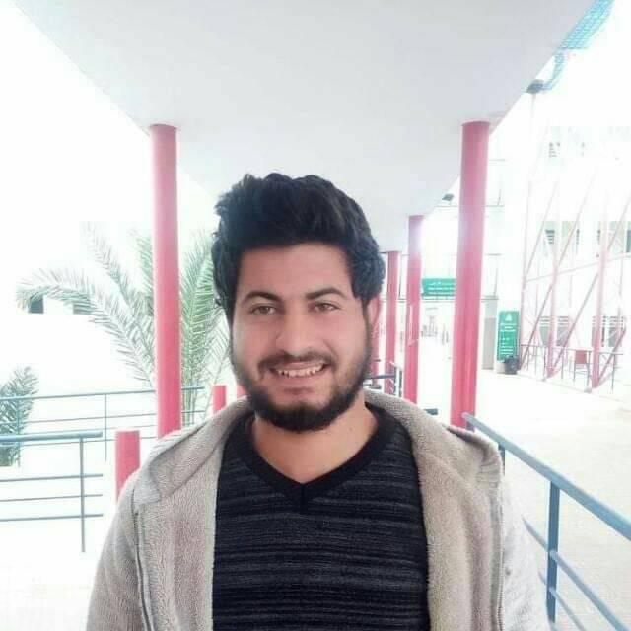

High Institut of technology sfax

**PROFESSIONAL EXPERIENCE**

IRIS clothes | Seller

Juin. 2015 - Sep. 2015

Hotel Mahdia Palace | Food sever

Juin, 2017 - Apr. 2018

Twitter

Facebook

**In progress: Applied degree in civil engineering**

High School ibn el Haythem Beja

**Technical Bachelor**

+97338701668

**PROFILE**

My training and my theoretical and practical knowledge revolve around the following topics: - Design and dimensioning of reinforced concrete structures and metal framework. (Buildings, industrial buildings, storage tank, silos ...). - Geometric design and dimensioning of pavement structures of road projects.

- Work planning and quality management. - Elaboration of tender documents as well as the files of executions. - Calculation of the estimates and estimates of the various reinforced concrete projects, road projects and VRD. - Calculation of superficial and deep foundations as well as the study of soil pathologies. - Rehabilitation of buildings, air conditioning, heating and electricity. - Seismic analysis of different structures.

Hamzarajhi733@gmail.com

Hammem Sayéla, Béja, Tunisie

* Allemand
* Français, Arabe
* Anglais

**23, Single**

**Hamza**

**Rajhi**

**CONTACT**

**LANGUAGE**

**TRAINING**

2015 – 2016

Auto Cad

Microsoft Excel

Microsoft Word

**SKILLS**

Skype

CRM

Excel